OPERATIONS MANUAL – A/C PREFERENCE DEVICE
- OVERVIEW
  - Purpose of Product
    - This Product allows for the optimization of individual preferences and integrates itself with the A/C system.
  - Goals
    - To identify and maintain a user specific room setpoint with minimal user data entry.
  - Verification
    - System accurately generates a comfortable setpoint for user. The setpoint is then compared to the actual room temp and achieves a zero-error state by varying the air volume entering a room. The system should reach desired setpoint in no longer than 30 minutes. The system then needs to maintain the desired setpoint until a new set point is desired. This system would’ve been verified to be accurate by using a fan to push air through a water to air heat exchanger. The cooled off air would then enter a duct where it would be channeled to different independent spaces. One of the spaces has a variable air volume diffuser at the end of it, controlling the air going into it, the other using a static diffuser, and does not vary the air entering. This is to replicate operating conditions. The space with the VAV diffuser would then have a room temperature sensor placed in it. The system would generate a set point for the space based off replicated user data. A trend report would then be constructed with varying the setpoints to reasonable temperatures and display the systems response to this.
- COMPONENTS/MODULES
- Mechanical Parts
- Diffuser
- Temperature Sensor
- Damper
- Actuator
- Microcomputer
- RFID tag
- RFID receiver
- Battery power

- Micro-Processor
Raspberry Pi Model B+
1.4 GHz 64-bit quad-core processor, dual-band wireless LAN, Bluetooth 4.2, 1GB SDRAM
- RFID
Mifare RC522 Radio Frequency Identification Reader/Cards
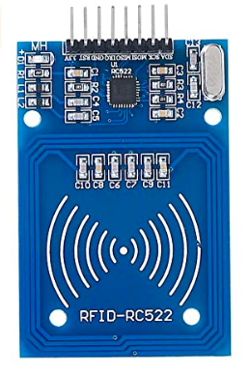

- INTEGRATION
- Overview
A- Micro-Computer B- Actuator/Diffuser C- RFID/User D- Temperature Sensor
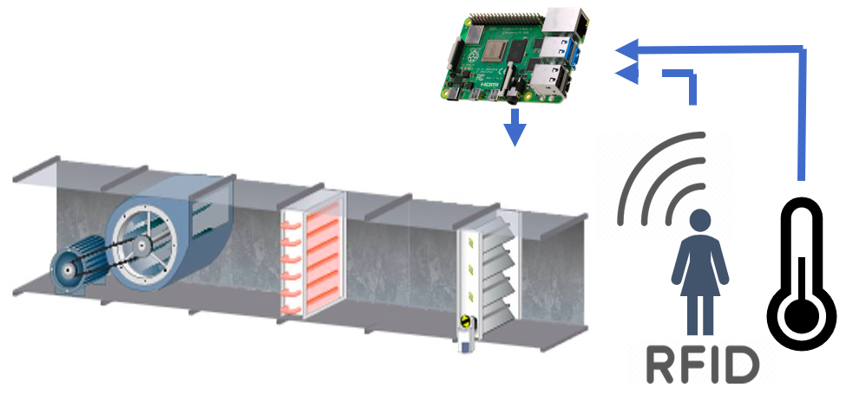
E- Fan/Heat exchanger (validation purposes)
A
B
C
D
E

- Raspberry Pi-RFID Wiring
SDA – PIN 24
SCK – PIN 23
MOSI – PIN 19
MISO – PIN21
GND – PIN 6
RST – PIN 22
3.3v - PIN 1
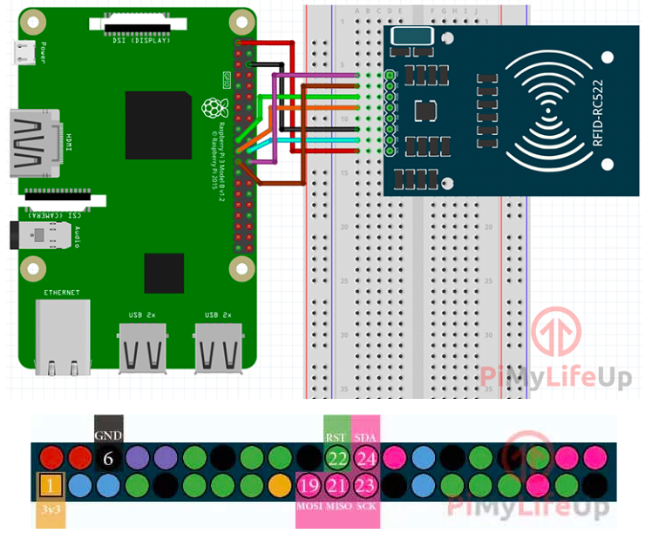
- Temperature Sensor Wiring
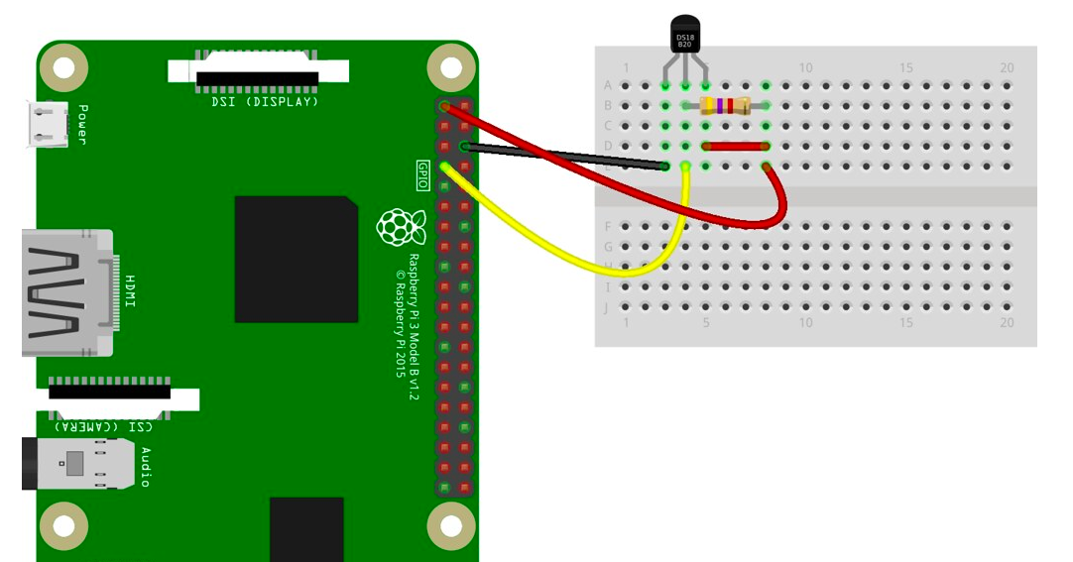
- INSTALLATION
  - Remove static air diffuser from ceiling by disconnecting duct work and taking out of ceiling grid.
  - Ensure battery of new VAV is connected and on.
  - Set up RFID connection by placing the card near the card reader.
  - Place new VAV diffuser in ceiling grid.
  - Re-connect the duct work to the new diffuser.
  - Mount the room temperature sensor in the ceiling grid no less than 6 feet away from the diffuser exit.
- OPERATION
  - Enter space and connect RFID card to the receiver. This ensures the system in occupied mode.
    - In unoccupied mode system is set to a minimum airflow.
  - Use push buttons to let system know if hot or cold at a given time.
  - System will respond by restricting or increasing the airflow into the space.
  - As user data is entered and stored the system will begin to work towards a certain setpoint.
    - Full autonomous operation is end goal.

- TROUBLESHOOTING
- Actuator for turning vent getting stuck
  - Dislodge unit from vent
  - Inspect Raspberry Pi for any foreign object lodged in between the piece
  - If there are not any foreign objects lodged between the piece, try lubricating the piece.
  - Clean dust from diffuser.
- Device is not modulating air temperature within the room
  - Check for device battery level for both units
  - Ensure there is airflow into diffuser.
  - Check for data input LED signal to flash. If there is no flash, then either there could be a loose cable in either units.
- SOFTWARE
- Code Repositories
  - Working Code - https://github.com/DarrylBrooks97/Senior-Design-AC-Prefrenece
  - RFID Libraries - https://github.com/pimylifeup/MFRC522-python
  - SQL Database - https://sqlite.org/src/doc/trunk/README.md
  - RFID Guide - https://pimylifeup.com/raspberry-pi-rfid-rc522/

- Code Overview
  - All code is written in Python 3. Raspberry Pi micro-computer runs main.py on startup. This program will check for RFID users via the MFRC522 library. Once user enters, data is logged in a SQL database using SQLite3 framework. When user presses hot/cold input, interrupt is triggered, and information is put into database. algo.py takes data from database and 1) Turns AC on to cool/heat room and 2) Optimize the preferred temperature for a specific user for future use. Sleep and interrupt commands must be utilized as to not hog the micro-computer’s resources, energy, and error handling.
- FUTURE WORK
- Prototype
  - Due to current events, a physical prototype will not be possible. However, we do plan on using some type of software to show that the unique predictive aspect of the project works as intended. Current suggestions on how to go about doing that include using Simulink or some other simulation-type software.
  - For a functioning physical prototype, an adjustable diffuser would be needed in order to be able to adjust the volume of air that is entering the room based on whether the cold or hot button is pressed by the user. This would have to be connected to the Raspberry Pi in order to read the data entered and properly alter the movement of the diffuser.
  - The diffuser would be connected to an actuator that would be able to move linearly in order to let the appropriate amount of air into the room.
  - For the actual device that we’ll plan on putting to market, the diffuser will have to be controlled by a stepper motor that will be able to adjust a damper that will modulate the volume of air that will be entering the room.

- Fine-tune Algorithm
  - Having data as massive as the amount that will be kept in order to predict future temperature preference, some future fine-tuning will be necessary in order to improve the predictability of the device. Some data will have to be continuously removed in order to make room for newer more relevant data. To have a more accurate prediction value, a moving average will be implemented so that the predicted value will not be an average of all the data previously inputted. The method of how to go about removing the appropriate amount of data will not be random and will require some type of logic-based algorithm.
- Market/License
  - After winning a $4,000 price at the InNolevation Challenge of the Jim Moran School of Entrepreneurship for most innovative project, a patent will be filed for the product. A Florida Limited Liability Company application will also be filed also to ensure manufacturing and marketing of the device. After the funds are received from the school of entrepreneurship, the manufacturing process for the device will be started. Following the manufacturing, the marketing process will start. The device will be marketed online and at retail stores. The cost of the product will be determined after the manufacturing process. The cost will also be determined depending on market conditions and considering similar products prices.

